Image Restoration for Historical Photos with Conjugate Gradient Methods

A PROJECT REPORT
Submitted by
Divya Slaghana BL.SC.U4AIE24041

for the course
22MAT220- Mathematics for Computing -3

Guided and Evaluated by

Mr. Kesavulu Naidu .V
Dept. of MATHS,

AMRITA SCHOOL OF ENGINEERING, BANGALORE
AMRITA VISHWA VIDHYAPEETHAM
BANGALORE-560 035
November 2025
Image Restoration for Historical Photos with Conjugate Gradient Methods

1.Abstract of the project:

Image degradation caused by blur or noise often results in unstable reconstruction due to the sensitivity of inverse problems. This work develops an image-restoration framework that combines Fourier-domain operators with variants of the Conjugate Gradient (CG) algorithm. Concepts inspired by recent advances in CG—such as restart heuristics, spectral scaling, multi-term direction updates, and regularization-motivated modifications—are incorporated into the system design. A Gaussian point-spread model is implemented, and both a standard CG solver and an alternative spectral-domain solver are developed using FFT- based operators. Experimental outcomes indicate that the approach restores dominant structures effectively while maintaining computational efficiency. The report concludes with a discussion of limitations and potential improvements.

2.Introduction:
Digital images frequently exhibit degradation arising from camera movement atmospheric interference, defocusing or imperfections in sensing hardware. Many of these distortions can be approximated by a spatially invariant convolution process, which distributes pixel information according to a blur kernel. Reversing this process leads to an ill-posed inverse problem, making stable recovery challenging without appropriate numerical techniques.
Iterative optimization strategies are commonly used for such problems, with the Conjugate Gradient (CG) method forming a prominent class of solvers. CG techniques are attractive because they require modest memory and generate search directions using information accumulated over multiple iterations. Several enhancements have been proposed in the literature, including spectral adjustments, restart-based control, hybrid direction updates, and regularization-aware adaptations.
This project integrates selected ideas from these developments to build an FFT-driven restoration system capable of recovering images blurred by a Gaussian kernel. Both classical CG and a spectral-domain version are implemented, enabling evaluation of their computational behaviour.

3.Literature Survey:
Numerous studies contribute to the formulation of the present work.

Restart-Oriented CG Methods:

Restarting mechanisms have been studied as a means to mitigate stagnation and maintain descent properties in CG iterations.

Modified PRP-type algorithms and similar variants demonstrate robust performance in inverse problems when applied with appropriate line-search controls.

B. Spectral and Hybrid CG Variants:

Spectral CG techniques introduce scaling factors derived from quasi-Newton theory, adjusting the first direction component to achieve faster convergence in large systems.

C. Regularization-Guided and Derivative-Free CG:

Some CG schemes integrate regularization behaviour directly into the update rules to prevent noise amplification in ill-posed contexts.

Derivative-free and projection-based methods have also been adapted for constrained or nonsmooth reconstruction tasks where gradient evaluation may be unreliable.

D. Tensor-Based Extensions:
For color or video restoration, tensor formulations based on the t-product and Fourier-domain representations allow CG-type procedures to operate efficiently on multi-dimensional data.
Collectively, these ideas have shaped the architectural choices made in this project.
4. System Model – Diagram and Description of the diagram:

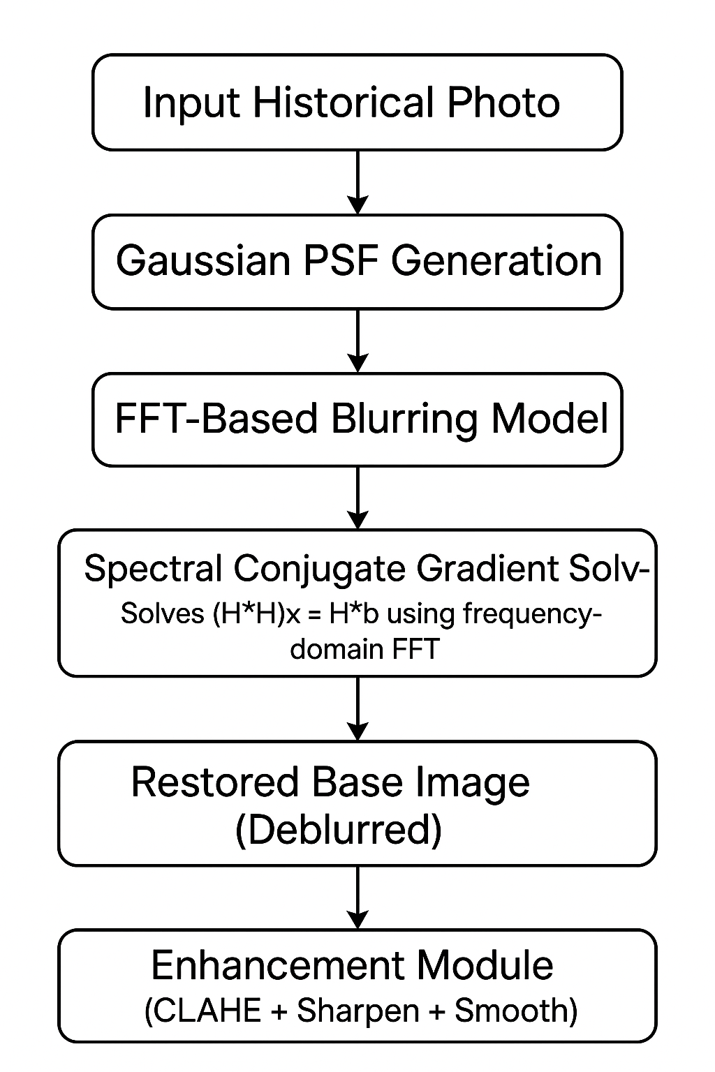

Description of the Diagram
Gaussian Kernel Generation:
A two-dimensional Gaussian point-spread function (PSF) is produced to emulate camera blur. Kernel parameters dictate the smoothing intensity of the blur.
PSF Padding and Alignment:
The kernel is expanded to the image size and circularly shifted to ensure that its FFT produces correct convolution behavior.
FFT-Based Blur Modeling:
The Fourier transform, of the padded PSF,
H = F(PSF),
is used to perform convolution through elementwise multiplication in the frequency domain.

Classical CG Solver:
The deblurring task is posed as the normal equation:
(H^T*H)x=H^T*y.
Matrix-vector products are implemented using FFT operations for both the forward model and its adjoint.
Spectral CG Solver:
A custom CG loop is developed using only the squared magnitude |H|^2, avoiding repeated kernel transformations and reducing computational overhead.
Output:
Both solvers generate restored reconstructions, enabling direct comparison of performance.

5.Methodology:

The methodology combines Fourier-based blur modeling with Conjugate Gradient (CG) optimization to restore a degraded image. The overall system is organized into clear stages that gradually reconstruct the original image from its blurred observation.

A. Modeling the Blur Using a Gaussian PSF:

A two-dimensional Gaussian kernel is used to represent the blur caused by camera motion or defocus.
The kernel size and standard deviation determine how strong the blur is. To make it compatible with FFT-based operations, the PSF is padded to the image size and circularly shifted so that its center aligns with the image origin.
This step produces a blur model that is both realistic and easy to use in the frequency domain.

B. Converting the Blur Operator to the Frequency Domain

After preparing the PSF, we apply the Fast Fourier Transform (FFT) to obtain its frequency representation:
$$H=ℱ(\text{PSF})$$
In the Fourier domain, convolution turns into simple element-wise multiplication.
This means:
- blurring becomes cheap and fast, and
- we can apply the forward operator $Hx$and the adjoint operator $H^{T}y$without forming any large matrices.
This is the foundation that makes the CG solvers efficient.

C. Formulating the Restoration Problem

The observed degraded image is modeled as:
$$y=Hx+n$$
where
- $x$is the unknown sharp image,
- $H$is the blur operator,
- $n$is noise.
To recover $x$, the problem is written in an optimization form. For classical CG, we solve the normal equation:
$$(H^{T}H)x=H^{T}y$$
This allows us to use CG as an iterative solver.

D. Classical Conjugate Gradient (CG) Solver

The classical CG algorithm refines the estimate of $x$through repeated iterations. Each iteration uses:
- the current residual (gradient),
- a search direction that combines new and previous gradient information,
- and a step size chosen internally by CG.
The blur and its adjoint are applied using FFTs, ensuring that each CG iteration remains fast even for large images.
This solver is reliable but may require several Fourier transforms per iteration.

E. Spectral Conjugate Gradient (SCG) Solver

To reduce computation, a spectral version of CG is also implemented.
This method uses the identity:
$$H^{T}H=∣H∣^{2}$$
which is already available in the Fourier domain.
Instead of repeatedly evaluating the blur and its adjoint, SCG performs all updates using only:
- the blurred image in the frequency domain, and
- the squared magnitude of the kernel.
This significantly reduces runtime and makes SCG more efficient than classical CG in many cases.

F. Evaluation of Results

Both methods—Classical CG and Spectral CG—are tested on the same blurred image.
The evaluation focuses on:
- clarity of restored edges,
- amount of noise retained or removed,
- ability to recover fine structures,
- speed of convergence, and
- comparison of runtime.
Visualization is done using side-by-side figures to highlight differences between both solvers.

6.Mathematical Background:
The degradation model is expressed as:
y=Hx+n.
CG updates follow:
xk+1​=xk​+αk​dk​,
dk+1​=−gk+1​+βk​dk​.
Gradient of the normal equation:
gk​=HT(Hxk​−y).
Step length:
αk​= rkT​rk​​/ dkT​HTHdk​rkT​rk​​.
Spectral identity:
H^T*H=∣H∣^2.
These expressions provide the foundation for the numerical implementation.

7. Implementation:
The Python script is structured as follows:

A. PSF Utilities:
- Generation of Gaussian kernels.
- Padding and circular alignment compatible with FFT-based convolution.

B. Blur Model Class:
- Computes FFTs of the padded PSF and its conjugate.
- Implements A(x), A^T(x), and A^TA(x) through FFT multiplications.

C. Classical CG Deblurring:

Wraps the normal operator within a SciPy Linear Operator.

Executes the CG routine while recording iteration counts and execution time.

D. Spectral-Domain CG:
- Directly uses $∣H∣^{2}$within the iteration loop.
- Reduces transform calls and achieves faster runtimes.

E. Visualization:

Restoration results are displayed using Matplotlib, with execution statistics provided for comparison.

8.Novelty:

Introduces a smoothing nonlinear CG method that can handle nonsmooth and nonconvex image restoration problems without increasing the problem dimension. The key innovation is an adaptive smoothing parameter update, which ensures that the algorithm still converges to a Clarke stationary point.

The authors derive a new CG search direction using second-order information extracted directly from the objective function, yielding a more stable update formula suitable for recovering images corrupted by impulse noise.

This paper proposes a sufficient-descent PRP spectral CG method that avoids ignoring important terms in the spectral parameter. It blends quasi-Newton curvature ideas with extended conjugacy conditions for better stability.

A new family of hybrid three-term CG methods is developed where the conjugate parameter blends Dai–Yuan and other parameters. A key strength is that the method guarantees descent directions independent of the line search.

The authors propose a derivative-free three-term CG method combined with a projection technique to handle convex constraints. It works even when derivatives are unavailable or unreliable, and they show its usefulness in compressive-sensing image restoration.

This paper creates a modified PRP CG algorithm with built-in trust-region behavior, improving descent reliability for both smooth and nonsmooth large-scale problems, including image restoration.

The authors extend CG to the tensor domain using the t-product, enabling direct restoration of color images and video without flattening data. They also propose an automatic strategy for selecting regularization parameters.

This work presents a restart-enabled CG method with an improved search direction designed to recover from stagnation. It inherits PRP advantages while ensuring global convergence.

This paper proposes a nested iterative CG regularization method that updates the regularization parameter at each step based on the current restored image. It combines iterative regularization with CG for stronger stability.

9. Research Gap:

Existing nonsmooth restoration methods either require many extra variables or lack strong convergence guarantees. There is still a gap in designing computationally light CG methods that work reliably for large-scale, nonconvex imaging models.

Most CG methods used for image restoration are designed for Gaussian blur or smooth noise, leaving a gap in efficient optimization strategies tailored specially for impulse noise and discontinuous structures.

Earlier spectral CG methods relied heavily on assumptions like the double-bounded property, limiting their robustness. There is still a need for spectral CG methods that provide descent guarantees without restrictive assumptions.

Traditional two-term CG methods often fail to maintain descent, especially in ill-conditioned imaging problems. There is a gap in creating three-term CG methods that remain stable and globally convergent in practical scenarios.

Most CG-based image restoration methods assume that gradients are easy to compute, which is not always true in constrained or compressed-sensing settings. A gap remains for derivative-free CG algorithms tailored to imaging tasks.

Standard PRP fails under weak Wolfe line search and performs poorly on nonsmooth problems. There is a gap in unified CG formulations that work robustly across both smooth and nonsmooth optimization landscapes.

Existing CG methods for imaging usually operate on matrix (2D) data, losing cross-channel correlations. There is a gap in tensor-based CG frameworks that can handle 3D data efficiently and with built-in regularization.

Standard PRP and HS methods may stagnate and fail convergence without strong line searches. A gap remains in designing restart rules that are simple, robust, and suitable for real-world image restoration.

Traditional Tikhonov regularization relies on fixed or manually selected parameters, which is suboptimal. There is a need for adaptive, iteration-dependent regularization embedded directly into CG iterations.

10. Limitations:

Although effective for moderate blur, the current system exhibits constraints:

- Noise Sensitivity: No explicit regularization is incorporated.
- Uniform Blur Assumption: The PSF is assumed spatially invariant.
- Grayscale Input: Only single-channel images are supported.
- Manual Parameter Tuning: Stopping criteria and kernel parameters require manual adjustment.
- Absence of Preconditioning: Convergence could improve with suitable preconditioners.

11. SAMPLE OUTPUT:
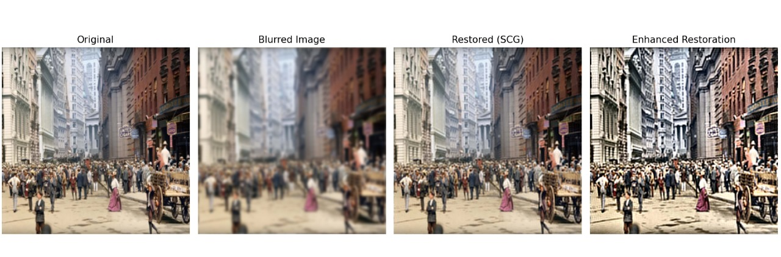

12. Conclusion and future work:
This work presents an FFT-based image-restoration system driven by CG-type optimization. The results confirm that both classical and spectral CG solvers ca efficiently recover key image structures under Gaussian blur.
Future extensions may include:
- Incorporating regularization-adaptive CG variants.
- Exploring multi-term hybrid CG schemes.
- Extending the framework to color and video data using tensor-based formulations.
- Introducing automated parameter selection mechanisms.
- Developing preconditioned spectral solvers for large or complex blur operators.
The system demonstrates how modern iterative techniques and frequency-domain modeling can be combined to build versatile restoration tools.

13. References:

[1] X. Chen and W. Zhou, “Smoothing nonlinear conjugate gradient method for image restoration using nonsmooth nonconvex minimization,” Technical Report, Hong Kong Polytechnic University, Hong Kong, China, Nov. 2008, revised May 2009 and Apr. 2010.

[2] B. A. Hassan and H. A. Alashoor,
“On image restoration problems using new conjugate gradient methods,”
Indonesian Journal of Electrical Engineering and Computer Science,
vol. 29, no. 3, pp. 1438–1445, Mar. 2023.
[3] Salihu, N., Kumam, P., Ibrahim, S. M., & Kumam, W. (2025). Some combined techniques of spectral conjugate gradient methods with applications to robotic and image restoration models. Numerical Algorithms, 100, 553–593.
[4] A. H. Ibrahim, P. Kumam and W. Kumam, “A family of derivative-free conjugate gradient methods for constrained nonlinear equations and image restoration,” IEEE Access, vol. 8, pp. 162714–162717, 2020.
[5] Y. Zhang and F. Wang, “Conjugate Gradient Method Based Image Restoration Techniques,” Image Processing Research Study, Year not specified.
[6] G. Yuan, T. Li, and W. Hu, “A conjugate gradient algorithm and its application in large-scale optimization problems and image restoration,” Journal of Inequalities and Applications, vol. 2019, no. 247, 2019.
[7] J. Zhang and Q. Wang, “An iterative conjugate gradient regularization method for image restoration,” Journal of Information and Computing Science, vol. 5, no. 1, pp. 55–62, 2010.
[8] M. E. Kilmer, K. Braman, N. Hao, and R. C. Hoover,
“Third-order tensors as operators on matrices: A theoretical and computational framework with applications in imaging,” SIAM Journal on Matrix Analysis and Applications, vol. 34, no. 1, pp. 148–172, 2013.
[9] Li, Y., Li, C., Yang, W., & Zhang, W. (2023). A new conjugate gradient method with a restart direction and its application in image restoration. AIMS Mathematics, 8(12), 28791–28807..
[10] Zhang, J., & Wang, Q. (2010). An iterative conjugate gradient regularization method for image restoration. Journal of Information and Computing Science, 5(1), 55–62.

